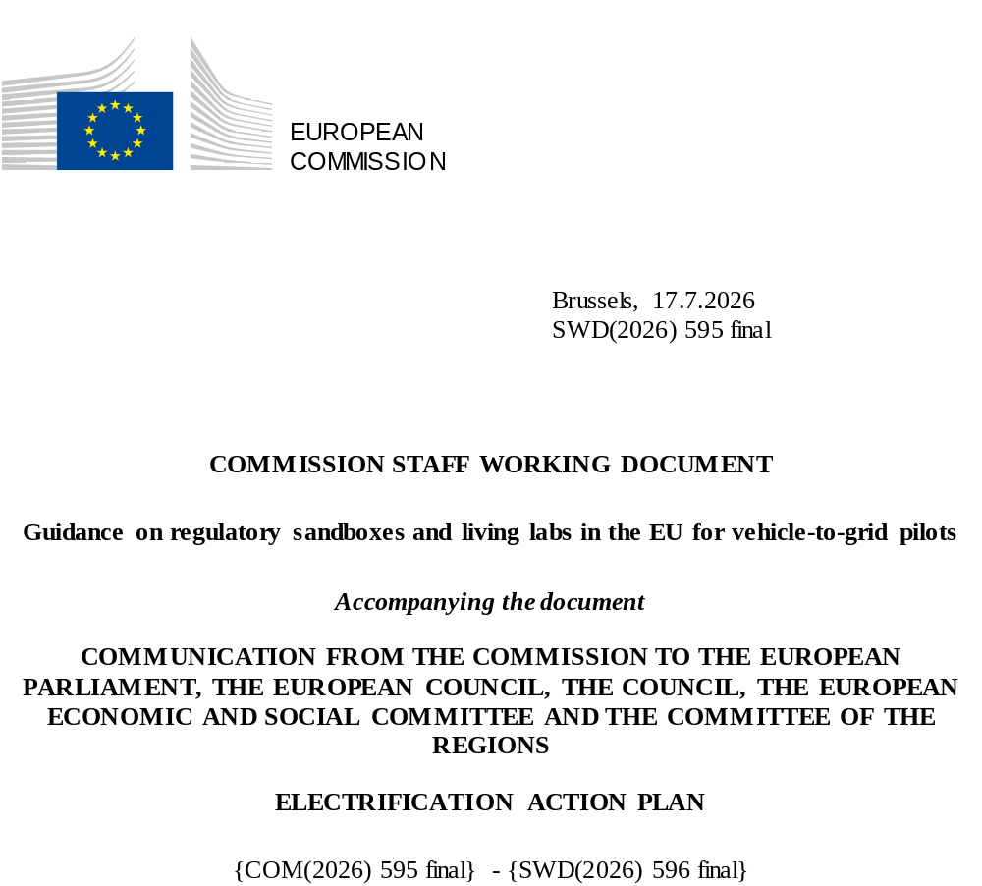

Contents

1. Introduction 3
2. Legal and policy context for experimentation on V2G 4
3. Regulatory Sandboxes for V2G pilots 6
3.1. Background 6
3.2. Existing regulatory sandboxes and national conducive enforcement of EU legislation 7
3.3. Opportunities and possible measures for regulatory sandboxes within the EU framework 10
4. Additional experimentation tools for V2G pilots 17
Annex: Examples outside the European Union 19

Glossary
Term or acronym | Meaning or definition
CAPEX | Capital expenditure
CPO | Charging point operator
DMD  DSO | Dedicated measurement device  Distribution system operator
ED | Electricity Directive
EMSP | E-mobility service provider
EV | Electric vehicle
EVSE | Electric vehicle supply equipment
GHG | Greenhouse gas
JRC | Joint Research Centre
MS | Member State
OEM | Original equipment manufacturer
NRA | National regulatory authority
PV | Photovoltaics
R&D | Research and development
R&I | Research and innovation
RES | Renewable energy sources
SME | Small and medium-sized enterprises
TSO  V1G | Transmission system operator  Unidirectional smart charging
V2G | Vehicle-to-grid
V2X | Vehicle-to-X

Introduction
The evolution of the EU’s electricity system, with an increasing role of variable renewable sources, is leading to growing flexibility needs. These needs will double in Europe by 2030.
The Draghi report highlighted the need for closing the innovation gap with the US and China, especially in advanced technologies. It also stressed the challenge of translating innovation into commercialisation and the regulatory hurdles faced by innovative companies that want to scale up in Europe.
To make progress in that direction, the Industrial Action Plan for the European Automotive sector, published in March 2025, has announced an initiative for the creation of regulatory sandboxes specifically designed for Vehicle-to-Grid (V2G) pilot projects to address regulatory, technical and market challenges before large-scale deployment. To support Member States progress, this Staff Working Document (SWD) outlines options and examples for establishing regulatory sandboxes, by utilising effectively the current Union legislative framework and exploring possibilities for experimentation with testbeds and living labs and for regulatory learning.
To reconcile innovation and regulation, the objective of this SWD is threefold:
- Explain how the current Union legislative framework can be enforced effectively by Member States to support and scale up V2G services.
- Explore how Member States could utilise experimentation tools such as regulatory sandboxes, testbeds or living labs, in order to support the deployment of V2G technologies
- Illustrate how some Member States have already implemented such legislative frameworks to allow possible replication of best practices.
Regulatory sandboxes mean structured frameworks that allow regulatory sandbox participants to experiment with an innovation for a limited time in a controlled environment, under the supervision of one or more competent authorities, and that results in evidence-based regulatory learning.
Living labs are another widespread experimentation tool to co-create, prototype, test and upscale innovative solutions to (local) needs in real-life settings.
To prepare the ground for this work, the Commission organised a consultation meeting with Member States and stakeholders on 23 June 2025. The participants underlined the importance of compliance testing through regulatory sandboxes across Europe. The 2024 joint report of the European Coalition of the Willing on bidirectional charging led by Germany, which associated around 500 stakeholders, also proposed to “create a sandbox environment by enabling and promoting pilot projects that investigate the contribution of bidirectional charging to grid stability, focusing on customer acceptance and grid serviceability. This could take the form of a time-limited trial phase, for exempting temporarily stored electricity from taxes, levies, surcharges, and some grid charges”.
Furthermore, on 20 May 2026, the Smart Energy Expert Group (SEEG), the Sustainable Transport Forum (STF), and the European Coalition of the Willing (CoW) on bidirectional charging published a joint Report identifying key roles, user scenarios, use cases, governance principles, and interoperability requirements that should now be tested and implemented across the EU.

Legal and policy context for experimentation on V2G
The EU regulatory and policy framework for the automotive sector supports the transition to clean mobility, ensuring that it contributes to climate neutrality and to strategic independence. This translates into clear incentives and rules on the transition from internal combustion engine (ICE) to zero emission vehicles.
With the growing share of electric vehicles (EVs) in the EU vehicle fleet, smart charging (V1G), as well as bidirectional charging and related vehicle-to-grid (V2G) services can facilitate the absorption of renewable generation and the decarbonisation of the energy system, provide flexibility to the electricity system and reduce the need for grid investments.
In particular, V2G has the potential to generate significant cost savings for consumers (both private and commercial). By remunerating them for reinjecting electricity from their vehicle batteries into the grid during peak periods or whenever electricity prices are high, V2G could offset a substantial share of charging costs, up to the full amount with the right conditions.
The current Union legislative framework provides incentives for tapping on the potential of V2G services to alleviate the grid and to save energy and costs for EV users:
- The Renewable Energy Directive (RED) allows Member States to choose between a 2030 target of 29% of renewables for the transport sector (all modes), or a reduction of 14.5% of the GHG intensity for fuels. Its Article 20a on energy system integration and e-mobility includes provisions to facilitate bidirectional charging. In particular, it requires battery-related data sharing at no cost in real time, or ensuring that private recharging points enable smart charging, and where appropriate, bidirectional charging. It also requires non-discriminatory participation of mobile assets in electricity markets.
- The Alternative Fuels Infrastructure Regulation (AFIR) foresees assessments by Member States every 3 years on the potential contribution of bi-directional charging. Its Delegated Act requires that from 1 January 2027 all recharging points comply with the relevant communication protocol that enables smart and bidirectional services (ISO 15118-20).
- The Electricity Directive and Electricity Regulation support the deployment and use of non-fossil flexibility sources, in particular through a specific assessment of flexibility needs at Member State level, and an indicative national objective for non-fossil flexibility. It provides the basis for non-fossil flexibility support schemes as reflected in the Clean Industrial Deal State Aid Framework. The electricity market framework also enables time of use tariffs, requests dynamic contracts for end users, but also enables citizens to have more than one metering and billing point covered by a single connection point for their premises or the right to request the installation of a smart meter within four months. This framework provides for the removal of double charges for active customers that own an energy storage facility.
In the context of the profound transformation of the energy and transport systems, experimentation is key to enable innovation and bring new technologies to market deployment and their integration in the energy system. If enforced effectively, the existing Union legislation allows Member States to create a conducive framework for innovative approaches to bidirectional charging. In addition, some Member States have in their national legislation provisions enabling the establishment of regulatory sandboxes or other forms of experimentation. Based on this national legislation, there are some existing regulatory sandboxes that are presented as examples below.
In 2023, the Commission published a Staff Working Document on ‘Guidance on regulatory sandboxes, testbeds and living labs in the EU’, presenting different tools enabling experimentation, namely regulatory sandboxes, testbeds and living labs. It also provided a specific focus on the energy sector.
In December 2025, the European Commission proposed amendments to this framework through the Automotive Package, setting out rules for the industry and Member States to adapt to clean mobility, while ensuring the competitiveness of the industry. The proposal on the Automotive Omnibus allows for the introduction of harmonised requirements into type-approval that would support the deployment of V2G.

Regulatory Sandboxes for V2G pilots

Background
Over the past decade, bidirectional charging has developed step by step. Initial progress came from small-scale pilot projects (such as Parker, GridMotion, and Electric Nation) which explored the flexibility potential of EVs, proved that V2G was technically viable, and examined user behaviour. Horizon Europe, the EU’s key funding programme for research and innovation, has funded demonstration projects to accelerate the development of V2X technologies and smart, interoperable and inclusive EV charging solutions, and overcome barriers to large-scale deployment.
As these pilots expanded to larger fleets and evolved into operational urban ecosystems, the main barriers shifted. As new models were designed and produced, technical feasibility was largely resolved. However, regulatory barriers to deployment were identified, especially at national level, preventing related business models from emerging: double charges and taxation for storage (during charge and discharge), lack of time-of-use network charges, issues with metering, limited market access for aggregators, lack of harmonization of grid connection requirements across the EU, interoperability, etc.
Several Member States began experimenting with (temporarily) relaxed or adapted rules to trial new tariff designs, market access conditions, metering configurations, and interoperability frameworks. This has been done both by adopting regulatory sandboxes or by adopting national laws that support bidirectional charging, in line with the EU enabling framework (see details in section 3.2 and 3.3). The Netherlands set up both a regulatory sandbox and a national-scale "living lab" for smart and bidirectional charging, In France, a commercial offer, backed by a regulatory sandbox, has been implemented to enable EV drivers to charge and drive at no cost using bi-directional charging. It can notably build on new negative network tariffs proposed by the national energy regulatory authority.
This SWD illustrates these good practices, and clarifies relevant use cases for regulatory sandboxes for vehicle-to-grid pilots. It aims to support regulators, competent authorities and innovators efforts to enhance experimentation and innovation in the EU, and to bring solutions closer to market deployment. More generally, de-risking innovation and fostering regulatory learning in specific contexts will pave the way towards a long-term regulatory framework supporting large-scale V2G roll-out.

Existing regulatory sandboxes and national enforcement of Union legislation

Regulatory sandboxes
There are two national regulatory sandboxes for V2G already being implemented and others under development, at different levels of maturity.
- Utrecht’s regulatory sandbox and 2026 Dutch Bidirectional Charging Roadmap
Utrecht in the Netherlands is among the first European cities to have developed a full-scale V2G ecosystem. The city collaborates closely with the Dutch DSO Stedin, charging operators, shared fleet operators and car manufacturers (including We Drive Solar, Renault and Hyundai) to integrate bidirectional charging into the local energy system.
Before national or European standards for V2G existed, Utrecht and Stedin, supported by the national government in a subsidy scheme, jointly designated an official experimental zone where V2G could be legally tested under controlled conditions. This local regulatory sandbox allowed deviations from standard concession rules and technical regulations and enabled real-life experimentation with bidirectional charging.
Key features of this regulatory sandbox included: (i) Installation and testing of bidirectional chargers in a defined neighbourhood; (ii) Bilateral data exchange between the city, the DSO (Stedin) and operators; (iii) Monitoring of technical performance, user behaviour and local grid impact; (iv) Using the lessons learned to inform later tenders and national discussions on flexibility markets and interoperability (ISO 15118, the National Charging Infrastructure Agenda – NAL).
After the regulatory sandbox proved that V2G was technically and operationally feasible, Utrecht integrated V2G into its procurement for public recharging stations. The city moved step-by-step from incentivising V2G to making it a default requirement in new tenders.
To complement the main city-wide concession for public charging, Utrecht introduced an open market model. This model allows mobility operators to apply for a permit to place a shared station next to their own recharging point, under clear and non-discriminatory conditions.
This approach ensures that:
  - Any shared mobility provider can request a permit to install its own charger next to a station-based vehicle, under the same rules;
  - Innovative V2G solutions can still be deployed even if a specific provider is not part of the main concession;
  - Use cases such as bidirectional fleets from We Drive Solar and MyWheels can scale in a way that remains compatible with the broader public charging strategy;
  - A level playing field is maintained while still giving room for frontrunners and new business models.
The Dutch national framework establishes the legal and regulatory environment that facilitates local experimentation and the gradual integration of Vehicle-to-Grid (V2G) technology into the energy system:
  - The Electricity Act, along with upcoming Energy Act reforms, provides options for DSOs to participate in innovation pilots under specific conditions;
  - The Experimental Regulation for Energy and Climate Innovation offers a formal foundation for municipal and cooperative experiments in the electricity domain;
  - The National Charging Infrastructure Agenda advocates for open standards, market-driven procurement and interoperability across various Dutch regions;
  - Guidance from the Netherlands Authority for Consumers and Markets ensures DSO neutrality while permitting cooperation in pilots fostering the energy transition.
Utrecht’s experience demonstrates how local regulatory flexibility, collaboration with competent authorities and developers, coupled with national legal instruments and an open market design framework, can accelerate the deployment of V2G while ensuring equitable market access. This combination of a local regulatory sandbox, V2G-centric procurement and an open market model presents a viable blueprint for other European cities aspiring to develop similar ecosystems.
On 22 June 2026, the Ministry of Infrastructure and Water Management sent its Roadmap on Bidirectional Charging to the Dutch House of Representatives. It creates the best circumstances for national scale up from 2030 (“national action agenda”). From 2030-2035, mass adoption is expected, with any vehicle being able to charge bidirectionally at any charging point. By then, bidirectional charging should also be required as a standard technology in tenders, and first bidirectional charging sessions will occur at public charging points. This follows the Utrecht experience.
- The French regulatory sandbox facilitating commercial roll out of V2G for citizens
In France, the Energy and Climate Act of 8 November 2019 established a regulatory sandbox in the energy sector. In certain cases, this mechanism enables the administrative authority or the Energy Regulatory Commission (CRE) to grant temporary exemptions (lasting four years and renewable once) to project developers. This allows them to go beyond certain provisions of the Energy Code.
Renault has been developing a V2G AC charging service since 2024. This offers an on-board bi-directional charger, a bi-directional recharging point, a Mobilize electricity contract supplied by its technology partner The Mobility House and a smartphone application enabling the customer to schedule charging. The project is aimed at domestic and non-domestic consumers with a low-voltage connection to the public distribution network in mainland France. The project has successfully commercialised V2G technology in France for private customers with the Renault 5, and is offering a viable business model where EV owners can save money from their car batteries. The V2G Service is now extended to all Renault and Alpine Electric Vehicle.
CRE has granted temporary exemption to The Mobility House, which will be able to choose, for its light-duty customers, an exemption tariff option incorporating signals to encourage these users to adopt behaviour that reduces peaks for the networks and the system. The services have therefore developed tariff schedules that include a negative coefficient during peak withdrawal periods for injection flows. During the high season, all days will include two two-hour peak periods.
France is also currently reflecting about:
  - testing sub-metering– using recharging point dedicated MID-certified meters - in a single-supplier setup and, potentially, in a multi-supplier setup
  - examining the technical compatibility between third-party metering (charging stations) and metering installed in the houses at the connexion point.
  - assessing the contractual possibilities and related obstacles in specific configurations: V2G + rooftop PV under a feed-in tariff scheme; V2H with self-consumption where none of the two energy sources is allowed to feed electricity back into the grid.
  - Dedicated energy contract for electric vehicle (charge & discharge V2X), independent from home energy contract.

National conducive enforcement of EU legislation
Conducive regulatory frameworks can support innovative solutions.
Double network charges on energy storage have been abolished in the vast majority of EU Member States. However, this does not mean that a comprehensive framework encompassing all energy storage technologies and establishing a level playing field with competitive technologies and market players (such as generators or active consumers) necessarily exists. In some cases, inconsistencies in the treatment of different energy storage technologies are present; in others, energy storage faces negative discrimination compared to generation, while in some instances, it could be argued that efforts to promote the deployment of energy storage have led to overcompensation with positive discrimination compared to customers.
The Commission is adopting a legislative proposal on future-proof electricity bills alongside this plan, which will ensure that network charges incentivise electrification, a flexible and system-friendly use of the grid, including treatment of storage installations and accelerating smart meter deployment.
Regarding energy taxes and levies that energy storage facilities face among the EU Member States, a third of Member Staes imposes double energy taxes and another third granting only partial exemptions.
In addition to examples quoted in 3.2.1, other Member States have legislated:
- In Germany, On 13 November 2025, the German Parliament adopted an amendment to the Energy Industry Act (EnWG) removing the double charging of grid fees for electricity fed back into the grid. E.ON and BMW then launched Germany's first commercial V2G product for citizens in 2026. Ford and Octopus Energy also introduced V2G charging for private customers in 2026.
- Sweden proposed changes to the energy tax system in 2018 to prevent double taxation on electricity storage.
- In Denmark, electricity used for EV charging is eligible for refund of electricity tax under specific conditions. Regarding metering, the Dedicated measurement device (DMD) in the wall box will be considered a ”commercial” metering point that can have a separate contract.
- In the Netherlands, the initiative GOPACS already allows local flexible resources to compete in the wider grid market.

Opportunities and possible measures for experimentation tools within the EU framework
Objective
Considering that real-world experience is crucial to accelerate the deployment of bidirectional charging solutions, this SWD introduces how different experimentation tools have been utilised recently within this thematical field. In addition, it provides support to Member States to address regulatory, market, and technical challenges, thereby facilitating the provision of V2G services.
By providing a structured yet flexible framework, as established in the Net Zero Industrial Act (Regulation (EU) 2024/1735), regulatory sandboxes may involve a temporary loosening or suspension of applicable rules during the test under certain conditions. Competent authorities may also provide participants with guidance to address legal uncertainty on how legal rules and requirements apply to specific products or services developed in the regulatory sandbox, and collect insights on possible further regulatory action to strike the right balance between facilitating innovation and mitigating risks.
Operational steps for regulatory sandboxes and other experimentation tools
Competent authorities of Member States in which regulatory barriers limiting V2G roll-out have been identified can, on a voluntary basis, create a special regime within their regulatory framework for a time-limited period, and with a defined scope.
Following the consultation with Member States and other stakeholders, the following guiding principles for creating and operating these special regimes have been identified:

- Customers and operators of charging infrastructure (CPOs) equipped with bidirectional charging functionality register for a test phase with the DSO via their V2G service provider, Flexibility service provider or aggregator.
- Customers can register for the test phase of the V2G service beyond initial launch of the V2G regulatory sandbox, thanks to a permanent window or successive rounds of submissions.
- Actions suggested for experimentation may be based on exemptions from the national regulatory framework (while always compliant with EU legislation), for a limited scope and limited period of time. They can relate to electricity taxation of energy stored, electricity network tariffs, remuneration with an incentive effect for customers, metering, grid codes, market access rules, local flexibility markets, V2G permitting, access to data, etc. All initiatives must comply with relevant legislation for example the Energy Taxation Directive.
- As relevant, customers, CPOs, DSOs, V2G service providers, Flexibility service providers or aggregators that have decided to subscribe to the test phase of the V2G service, participate in the relevant projects, and agree to share the necessary data for evaluation purposes.
- Feedback from stakeholders is published to support knowledge sharing and lesson learning for evidence-based decision making.

A continuous dialogue between Commission services and voluntary Member States will allow the sharing of best practices and lessons learnt. This dialogue will happen every 6 months, using an existing body, such as the current cooperation framework on smart and bidirectional charging (Data for Energy (D4E)/Sustainable Transport Forum (STF)/CoW). At the first meeting, Member States will be encouraged to identify the opportunities and drivers for regulatory sandboxes and/or living labs at their level, ie by providing a list of concrete projects to be implemented.

Scope
Since a critical mass is needed to identify what business cases for V2G are commercially viable and scalable, competent authorities in voluntary Member States could define the scope of the regulatory sandbox on the basis of the obstacles faced by the relevant use cases and target pre-defined pools of private or corporate users, such as: households using private or shared charging infrastructure, corporate HDV or LDV fleets charging in depots (large lease companies, public car sharing, public transportation, municipalities, …), car sharing fleets in cities, etc.

Defining the scope also requires reference to a geographical territory, which can range from the whole national territory to e.g. specific regions, cities or islands.
Moreover, if the measures listed below fit with V2G schemes, most of them would also be beneficial to V1G (smart charging).
Participating stakeholders will take the following considerations into account: Their involvement is expected to bring added value to the European mobility and transport value chain, including automotive and related smart mobility sectors, and to help identify strategic domains that help enhance European competitiveness.

Measures that Member States may take forward to advance V2G deployment
This section shows indicative measures that Member States and national competent authorities could take to advance V2G deployment, possibly complemented by additional measures. This list has been shaped with stakeholders and Member States, highlighting existing provisions of EU legislation that are conducive for bi-directional charging:

National schemes of taxation and tariffs
A1 - Prevent double taxation
What? The European Commission recommends Member States to take into account the double role (generator-consumer) of energy storage when defining the applicable regulatory framework and procedures, in particular when implementing the Union legislation concerning the electricity market, in order to remove existing barriers. This includes preventing double taxation […]. National regulatory authorities should also consider such a role when setting network charges and tariff schemes, in compliance with Union legislation.
Who? Member States and NRAs
Why? To avoid that the same energy is taxed twice and improve the business case for V2G.
A2 – Incentivise grid-friendly behaviours through tariffs
What? Time-of-use (ToU) tariffs and abolishing double charges, including network charges, for consumers with energy storage are part of the EU legislation (Article 18 of Electricity Regulation 2019/943, and Article 15 of Electricity Directive 2019/944). The network tariff design can be improved:
- Option 1a: Via “Time of use” (ToU) and dynamic network charges that are cost reflective, possibly integrating a “negative” tariff for injecting energy into the grid in peak consumption hours, or for consuming power to alleviate local grid stress from usual RES-peaks and returning this power to the grid at a later time; close attention should be paid to reflect the actual added value of V2G for the grid.
Example: the customer charges the EV at midday when there is excess solar generation and allows the EV to discharge power back to the grid in the evening peak. Thanks to the specific network charges proposed by the NRA, the customer benefits from close to zero or negative network charges for this charging behaviour.
- Option 1b: Via an hourly injection tariff that gives an implicit signal of grid congestion.
Example: a dynamic injection price possibly indexed to hourly prices promotes injection and consumption at the most profitable and grid-friendly time. When the grid is congested and energy price is high, the injection tariff is high (the customer earns more by discharging the EV), and when the energy price is low reflecting a period of high renewables infeed, the injection tariff is close to zero or even negative (the customer is incentivised to charge the EV).
- Option 2: Via exemptions from network charges in order to take into account the benefits of storage for the grid and incentivise grid-friendly behaviour. Close attention should be paid to avoiding that undifferentiated exemptions encourage V2G injections at moments that contribute to increasing the stress of the local grid, for example when it is already overburdened by excessive local renewables.

Example: when the local grid is congested (for instance due to high solar PV feed-in), the customer is not encouraged to inject electricity into the grid, but to charge at that point in order to absorb this excess renewable electricity, thanks to an exemption of network charge for this behaviour. On another day, when the grid needs more generation, V2G injections may be exempted from network charges for certain hours.

- Option 3: Via lump sums, or fixed amount of support for V2G use

Example: the customer receives a monthly or annual payment to make the EV battery available for grid services under predefined contractual conditions: for instance, 9kW subscription without V2G activated: €15/month, and with V2G activated: €12/month, with the discount only applied if there has been actual injection within the month in times of peak consumption pre-defined by the DSO (e.g. evenings from 17.00-20.00).
Methodologies should be consistent across all system operators in the same Member State, within the defined scope of the experimentation.
Who? NRAs, TSO/DSOs
Why? Network tariff design is a key tool to create incentives for V2G customers to adapt their behaviour to the situation in the grid.

Market aspects
B1- Remunerate flexibility through dynamic electricity price contracts
What? Under Article 11 of Directive 2019/944, Member States must enable suppliers to offer dynamic electricity price contracts. A guidance on flexible retail contracts was adopted on 30 April 2026. It provides practical guidance on promoting the remuneration of flexibility in retail contracts, including dynamic price and hybrid contracts.
Who? Member States, energy suppliers
Why? Amongst others, dynamic price contracts can facilitate the integration of EVs, by incentivising charging when RES electricity is abundant, providing cost savings for both the energy system and the consumers.
B2 - Allow that flexibility service providers (including EMSP) act as aggregators on behalf of the EV user
What? Directive 2019/944, Art. 17 enables flexibility services, for instance through aggregation and the development of virtual power plants, based for example on recharging points. To extend the service to charging in public recharging points, CPOs would have to take part to an agreement with aggregators, or act as such.
Who? Member States
Why? In private (home, workplace) and public charging (mostly AC), the aggregator plays a key role in bridging the gap between energy/network pricing/market mechanisms, user needs and preferences, and EV charging.
B3 - Bid forward between local markets and national or EU-wide wholesale markets
What? It refers to the ability of a market participant (e.g., an aggregator) to submit energy or flexibility offers from local systems into national or European electricity markets, so that local flexible resources can compete in and support the wider grid. Member States must assess local and system-wide flexibility needs, under Articles 31 and 32 of ED, and Articles 6, 7 and 57 of Electricity Regulation.
Who? Member States, NRAs, DSOs & TSOs
Why? Close cooperation between DSOs and TSOs is needed to ensure that the available flexibility is absorbed by the market where it is most needed and to avoid conflicting activations, duplicate prequalification and further fragmentation.
B4 - Reduce minimal requirement for qualifying and participating in ancillary service and congestion management markets
What? This action can apply for instance to a level of 100kW/market participant (equivalent to 10 cars or 3 trucks in the case of aggregators managing EV charging fleets) instead of - in some cases - a magnitude of MWs. The EU network codes currently define the highest minimum bid size but allow for NRAs and system operators to opt for lower granularities.
Who? NRAs, TSOs, DSOs and aggregators
Why? To take into account the specificity of vehicles in ancillary service and congestion management markets.
B5 – Encourage consumers to self-consume electricity stored in their vehicle battery at peak times (V2H)

What? Without the intervention of any aggregator, consumers can self-consume the electricity stored in their battery, possibly together with electricity production from PV panels.

Who? MS, DSOs, energy suppliers and consumers

Why? Allowing consumers using bi-directional charging to behave as self-consumers and avoiding the intervention of any aggregator while developing their demand response capabilities would enhance the business case for EV owners and limit grid investment.

B6 – Allow consumers to benefit from renewables self- consumption regimes for reinjecting electricity from their EVs into the grid

What? This regime would be similar to the existing framework for renewables self-consumers, established in Article 21 of the Renewable Energy Directive and Article 15 of the Electricity Market Directive. Unlike the system designed primarily to encourage the development of renewable energy sources, a potential framework for EV owners would focus on incentivising the injection of electricity at times that are advantageous to the grid. It would be made possible whenever EV owners have access to dynamic retail contracts, real-time prices or variable tariffs (notably thanks to dedicated reinjection tariffs – See option 1 of Action A2 above) to ensure that they can adequately react to price signals and reinject at the right time. In case of PV panels, it would require sub-metering to distinguish between energy flows.

Who? MS, DSOs, energy suppliers and consumers

Why? By allowing consumers using bi-directional charging to behave as self-consumers and avoiding the intervention of an aggregator while developing their demand response capabilities, this would enhance the business case for EV owners, incentivise grid-friendly behaviour and provide flexibility to the energy system.

Complementary supporting measures
C1 - Encourage implementation of demand response protocol
What? In the context of EV charging, a demand response protocol allows the DSO to communicate grid-related signals, such as congestion alerts, load-reduction requests, flexibility events, time-dependent constraints, or dynamic price signals, and the CPO or the owner of a vehicle fleet who operates its private recharging points to respond with available flexibility, planned load, confirmation of actions taken, and site-level operational constraints.
Who? DSO/CPO and aggregators
Why? To support smart charging and discharging based on grid needs, CPOs and DSOs should synchronize their needs and capabilities in real time. A demand response protocol enables efficient, standardized and interoperable communication between EVs, chargers, grid operators and aggregators.
In California, the OpenADR 2.0b protocol is required for demand-responsive controls in non-residential settings, enabling automated load management and integration with utility signals. IEC 63584 and ISO 15118-20 are increasingly used for charger-to-network and vehicle-to-charger communications, supporting features such as Plug & Charge and DC bidirectional operation.
C2 - Ensure V2G can provide power during emergency situations
What? Exceptionally, in case of emergency situations such as black-outs, it should be possible for the EVSE and the EV to communicate in a minimal, safe-only mode to establish secure charging communication without the required charging certificates.
ISO 15118-20 allows for the disabling of charging certificates (See Annex H.3 of ISO 15118-20:2022). This entails that the communication protocol falls back to only the safety related parts (e.g. voltage negotiation).
Who? EVSE and vehicle manufacturers
Why? To provide for emergency power during blackouts, such as recently seen on the Iberian Peninsula.
Japan’s experience highlights the integration of V2X into disaster resilience and public benefit, even as mass-market BEV adoption remains limited. The government’s guidelines, updated in 2023, explicitly promote V2X solutions and provide targeted support for the installation of V2H charging and discharging equipment in private homes, public facilities, and disaster centres. Subsidies are structured to incentivise installations that can provide backup power during outages, and public sector actors such as TEPCO, the largest electricity power company in the country, and other regional utilities are actively involved in V2G and microgrid pilots.
C3 – Facilitate and streamline procedures for V2G grid connection
What? A standardized digital procedure, including necessary certifications and documents for V2G permitting that DSOs will use and share, would help facilitate and streamline procedures for V2G grid connection.
Who? DSOs, National authorities and aggregators
Why? DSO input is essential in designing templates and digital platforms.

Additional experimentation tools for V2G pilots
On top of the regulatory sandboxes described in section 2, market players may also create the conditions for innovative business models, such as living labs, that support V2G thanks to specific frameworks as described below:
D1 –Provide pricing signals in public recharging points
What? For public AC charging, CPOs can offer smart charging directly or through an EMSP (see example in Amsterdam). The CPO provides pricing signals to the end user directly or through the EMSP, which then results in an optimal charging plan based on the user's departure time and battery percentage retrieved from the back-end server of the vehicle manufacturer (allowed by RED Art. 20a).
Who? CPOs, EMSP
Why? To unlock greater EV flexibility in public charging, CPOs can pass on the price and time variations of a network tariff and dynamic electricity price. This would encourage off-peak charging, and limit grid reinforcements investments.

D2 – Recommend vehicle manufacturers to implement communication standard ISO 15118-20 in the EV
What? From 1 January 2027, publicly accessible recharging points and private recharging points are required to implement ISO 15118-20 (both AC and DC charging). EVs are encouraged to also implement this important standard.
Who? Vehicle manufacturers
Why? The implementation of ISO 15118-20 allows multiparty interoperability; it is crucial to carry out testing to ensure the prompt market implement of this standard in an interoperable manner, and thus, avoid the use of proprietary solutions.
D3 – Enable disaggregation of demand resources through appropriate metering arrangements (MID certified submeters and separate accounting in case of PV).
What? Utility meters, including MID compatible submeters, and, where applicable, DMDs, can be used as official meters, in addition to the smart meter at the grid connection point, to distinguish between injected energy sourcein line with Art 4 of the ED and Art 7b of the Electricity Regulation. Customers can opt for an additional supply contract under the same connection to the grid, facilitated by smart meters and submeters. Therefore, the framework allows for different ‘accounting points’ within consumer’s premises, e.g. EV, HP, or other house load. Other provisions, such as Art. 15 of the ED on active customers, or the smart metering provisions, also facilitate such services.
Who? Vehicles manufacturers, suppliers, DSOs and aggregators
Why? This specific metering arrangements would enable a dedicated V2G energy contract, by facilitating separate metering of charging/discharging flows from other flows (i.e. electricity generated by solar panels).

Annex: Examples outside the European Union
Across the world, pilot projects and regulations for V2G are also flourishing. These initiatives started to provide the basis to understand how V2G can operate in real-world regulatory and market environments. International studies reveal that successful deployment of bidirectional charging hinges on strong policy direction and harmonised technical standards. Best practices emphasise interoperability, consumer value, and integration with broader energy and transport strategies.
The United Kingdom’s centralised regulatory approach has mainstreamed smart charging and enabled high reliability and consumer protection, while bidirectional charging is advancing through targeted trials. Notable projects include Project Sciurus, which trialled over 300 domestic V2G chargers, and recent partnerships between energy suppliers (e.g., EDF, Octopus) and automakers (notably Nissan and BYD) to launch V2G-ready vehicles and bundled charging solutions.
California is widely recognised as a global frontrunner in the deployment of smart and bidirectional charging. The state’s approach is shaped by a suite of supporting policies that include the Vehicle-Grid Integration (VGI) policy track, and the National Electric Vehicle Infrastructure (NEVI) standards. California’s regulatory environment also supports open access, transparent pricing, and interoperability. The State enforces essential standards for BDC and V2G applications.
China stands out as the world’s largest and most rapidly evolving market for EVs. China’s approach to V2G is particularly ambitious: in 2025, the government launched 30 large-scale V2G pilot projects across nine major cities, requiring grid companies to provide metering and dispatch support for EVs acting as distributed energy resources. The regulatory framework is highly centralised, with the National Development and Reform Commission (NDRC) and the National Energy Administration setting clear targets and technical standards. These standards ensure interoperability, with compulsory certification for all new charging equipment. The grid planning explicitly incorporates EV flexibility, with virtual power plant targets of 20 GW by 2027 and 50 GW by 2030. All new charging infrastructure must support smart charging, with support for dynamic pricing, demand response, and aggregator participation, and direct integration into utility platforms. Provinces such as Jiangsu have introduced discharge tariffs for V2G, with household earnings of up to ¥3,000 per year (around 360€).
South Korea is also actively piloting bi-directional charging, particularly V2G and V2H applications. South Korea runs a broad regulatory sandbox system. Notable projects include the Jeju Island V2G pilot (Hyundai and KEPCO), where EVs are used to stabilise the grid during peak demand. South Korea has corporate fleet and public bus initiatives exploring virtual power plant (VPP) aggregation.
Australia has an energy regulatory sandbox toolkit. It is leveraging its high rooftop solar penetration and national standards to build a foundation for managed and bidirectional charging. The Australian Renewable Energy Agency (ARENA) published the National Roadmap for Bidirectional EV Charging in February 2025. Major energy retailers such as Origin Energy and AGL are actively involved in trials: Origin, in partnership with BYD and StarCharge, is running a 12-month pilot with 50 households to test managed charging and V2G, while AGL and ARENA are conducting a national trial with 100 EV owners from multiple automakers to explore peak shaving and frequency control.
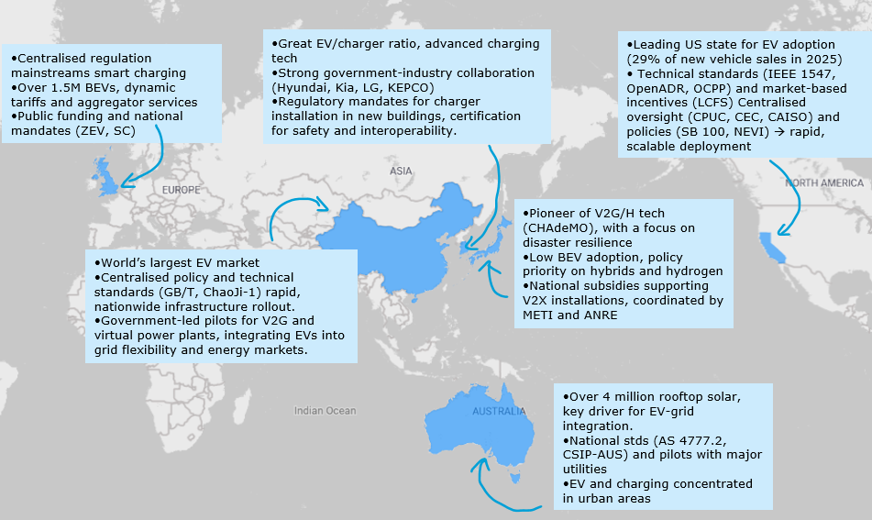
Figure 1 - Overview of key points in different countries (source: Ramboll study)

X= everything: home, buildings, vehicle, load, grid, …
ACER-CEER 2024 Market Monitoring Report on Energy Retail and Consumer Protection
As referred to in the ‘Guidance on regulatory sandboxes, testbeds and living labs in the EU’ (SWD(2023) 277/2 final)
They also commented on the role and definitions of EMSPs and aggregators, the involvement of DSOs and TSOs in virtual power plants, and the potential of EVs to support the grid in emergencies.
https://www.bundeswirtschaftsministerium.de/Redaktion/DE/Downloads/P-R/coalition-of-the-willing-on-bidirectional-charging-en.pdf?__blob=publicationFile&v=8
https://op.europa.eu/en/publication-detail/-/publication/f56915a6-5582-11f1-b3e2-01aa75ed71a1/language-en
Directive (EU) 2023/2413 of the European Parliament and of the Council of 18 October 2023 amending Directive (EU) 2018/2001, Regulation (EU) 2018/1999 and Directive 98/70/EC as regards the promotion of energy from renewable sources
A Commission guidance on the application of these requirements was adopted in July 2025 (C/2025/4104)
REGULATION (EU) 2023/1804 OF THE EUROPEAN PARLIAMENT AND OF THE COUNCIL of 13 September 2023 on the deployment of alternative fuels infrastructure, and repealing Directive 2014/94/EU
Commission Delegated Regulation (EU) 2025/656 of 2 April 2025 amending Regulation (EU) 2023/1804 of the European Parliament and of the Council as regards standards for wireless recharging, electric road system, vehicle-to-grid communication and hydrogen supply for road transport vehicles
DIRECTIVE (EU) 2024/1711 OF THE EUROPEAN PARLIAMENT AND OF THE COUNCIL of 13 June 2024 amending Directives (EU) 2018/2001 and (EU) 2019/944 as regards improving the Union’s electricity market design
REGULATION (EU) 2024/1747 OF THE EUROPEAN PARLIAMENT AND OF THE COUNCIL of 13 June 2024 amending Regulations (EU) 2019/942 and (EU) 2019/943 as regards improving the Union’s electricity market design
Framework for State Aid measures to support the Clean Industrial Deal (Clean Industrial Deal State Aid Framework)
SWD(2023) 277/2 final
COM(2025) 993 final: “ The Commission is empowered to adopt delegated acts aimed at setting out technical requirements for pure electric vehicles (PEV) and off-vehicle charging hybrid electric vehicles (OVC-HEV), as regards their communication and hardware interface of those vehicles with the recharging infrastructure, the electricity grid and the stationary power systems capable of supporting smart and bidirectional charging functionalities”.
V2X=Vehicle-to-everything (eg vehicle-to-buildings, vehicle-to-home, vehicles-to-load, vehicle-to-grid)
See for example the V2X Cluster of projects: https://ev4eu.eu/v2xcluster/.
Smarten study “Assessment of the regulatory framework of bidirectional EV charging in Europe” (December 2023) or EY/Eurelectric study “Plugging into potential: unleashing the untapped flexibility of EVs” (March 2025)
Notably allowing consumers to be remunerated when they inject electricity into the grid at the right time (ie when electricity price is high or renewables production is low), with static or dynamic predefined timeslots.
https://www.tweedekamer.nl/kamerstukken/brieven_regering/detail?id=2026Z14132&did=2026D31669
These peak periods will be set by the network operator and will occur between 7 a.m. and 10 a.m., and between 6 p.m. and 9 p.m.
2026 JRC report on Implementation of Commission Recommendation on Energy Storage in the Member States: https://publications.jrc.ec.europa.eu/repository/handle/JRC144586
2026 JRC report on Implementation of Commission Recommendation on Energy Storage in the Member States: https://publications.jrc.ec.europa.eu/repository/handle/JRC144586
https://www.mobilityhouse.com/int_en/our-company/newsroom/article/german-parliament-removes-key-barrier-to-bidirectional-charging-vehicle-to-grid-becomes-possible
https://www.riksdagen.se/sv/dokument-och-lagar/dokument/proposition/vissa-kontrollfragor-och-andra-fragor-pa_h503294/, and https://smarten.eu/wp-content/uploads/2023/12/V2X-Enables-and-Barriers-Study_11-2023_DIGITAL.pdf
https://www.eu.dk/samling/20251/lovforslag/L25/index.htm?utm
https://www.gopacs.eu/en/who-owns-gopacs/
Coalition of the willing on bidirectional charging
COMMISSION RECOMMENDATION 2023/C 103/01 of 14 March 2023 on Energy Storage – Underpinning a decarbonised and secure EU energy system - https://eur-lex.europa.eu/legal-content/EN/TXT/PDF/?uri=CELEX:32023H0320(01)
1. Charges applied by network operators for access to networks, including charges for connection to the networks, charges for use of networks, and, where applicable, charges for related network reinforcements, shall be cost-reflective, transparent, take into account the need for network security and flexibility and reflect actual costs incurred insofar as they correspond to those of an efficient and structurally comparable network operator and are applied in a non-discriminatory manner.
Article 15: Active customers “Member States shall ensure that active customers that own an energy storage facility are not subject to any double charges, including network charges, for stored electricity remaining within their premises or when providing flexibility services to system operators;”
Article 11 – Right to a dynamic electricity price contract: “‘1. Member States shall ensure that the national regulatory framework enables suppliers to offer fixed-term, fixed-price electricity supply contracts and dynamic electricity price contracts. Member States shall ensure that final customers who have a smart meter installed can request to conclude a dynamic electricity price contract and that all final customers can request to conclude a fixed-term, fixed-price electricity supply contract with a duration of at least one year, with at least one supplier and with every supplier that has more than 200 000 final customers.”
https://energy.ec.europa.eu/publications/report-market-based-electricity-supply-prices_en
Such as OpenADR (IEC 62746) that provides a common and interoperable communication protocol for Automated Demand Response (ADR)
Both the EVSE and the EV should have a documented switch to a safe-only mode setting that can disable these certificates. For security reasons, the EVSEs should only allow the activation of this safe-only mode after physically opening the enclosure unit of the system by a trained technician, with simple configuration tools.
https://alternative-fuels-observatory.ec.europa.eu/general-information/news/amsterdam-launches-smart-charging-pilot-reduce-grid-load-and-charging
In Italy, the ’Tariffa BTVE’ which applies to public AC recharging points, shifts parts of the fixed costs to time-varying, volumetric costs.
Under AFIR Delegated Act on Standards (OJ L, 2025/656, 18.6.2025)
Dedicated measurement devices, e.g. in the recharging point
ie V2G or PV, as each source can have a different buyer
Analysis based on a study made by Ramboll for the European Commission in 2025-2026: https://op.europa.eu/en/publication-detail/-/publication/170d3b45-7753-11f1-bf5e-01aa75ed71a1/language-en .
IEEE 1547/UL 1741 SB for smart inverters and export-capable EVSE
https://op.europa.eu/en/publication-detail/-/publication/170d3b45-7753-11f1-bf5e-01aa75ed71a1/language-en

